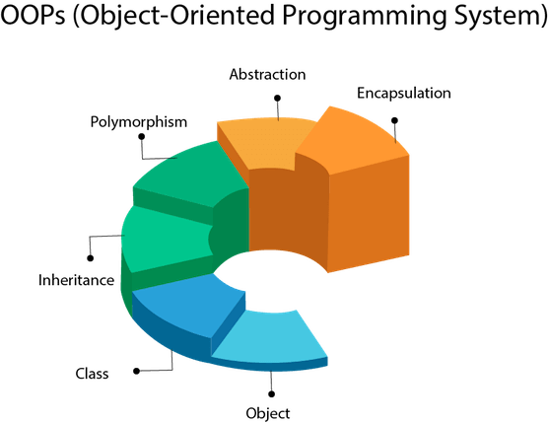

Object Oriented Programming Study

A self-study of OOP and how I apply it into my programming…

By Ian Teves - 01/25/2022

Table of Contents

Introduction to OOP 3

# Introduction to OOP

Object-oriented programming (OOP) is a programming paradigm that is based on the concept of "objects", which can contain data and code that operates on that data. A programming paradigm is a way of thinking about and approaching the task of programming. OOP is designed to increase the reusability and maintainability of code by organizing it into small, modular units called classes. Each class defines an object's characteristics and behaviour. OOP also encourages the use of inheritance and polymorphism, which allows developers to create a hierarchy of classes and create objects that can be treated as instances of more general classes. Overall, OOP aims to make code more modular and easy to understand, which can lead to more efficient and robust software development.

## How do computers work?